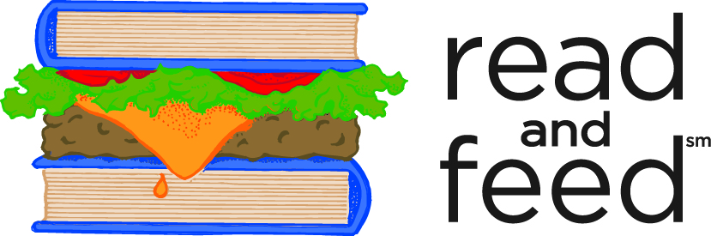
Book Donation Guidelines
Thank you for your interest in donating books to Read and Feed. We appreciate your help in giving kids in Wake County an appetite for reading! Please make sure to complete our in-kind donation form so that we can send you an acknowledgement of your tax deductible donation.
Series currently in demand:
National Geographic Kids! Scholastic Levels (K-5) readers
Step Into Reading levels (K-5) I Can Read Levels (K-5)
Magic Treehouse (K-5) A to Z Mysteries (K-5)

We do not accept:
- Textbooks
- Books written in languages other than English
- Dictionaries/Thesauruses
- Encyclopedias
- Board Books
- Religious-themed books

We accept:
- Kindergarten through 5th grade reading levels
- Gently-used books that do not show signs of discoloration/age
- Gently-used books that do not show damage from mold, water or fire

Donation drop-off location:
Read and Feed Office
193 High House Road
Cary, NC 27511
(919) 538-3840

*Please call the Read and Feed office regarding book donation pickup, as available.

